1. 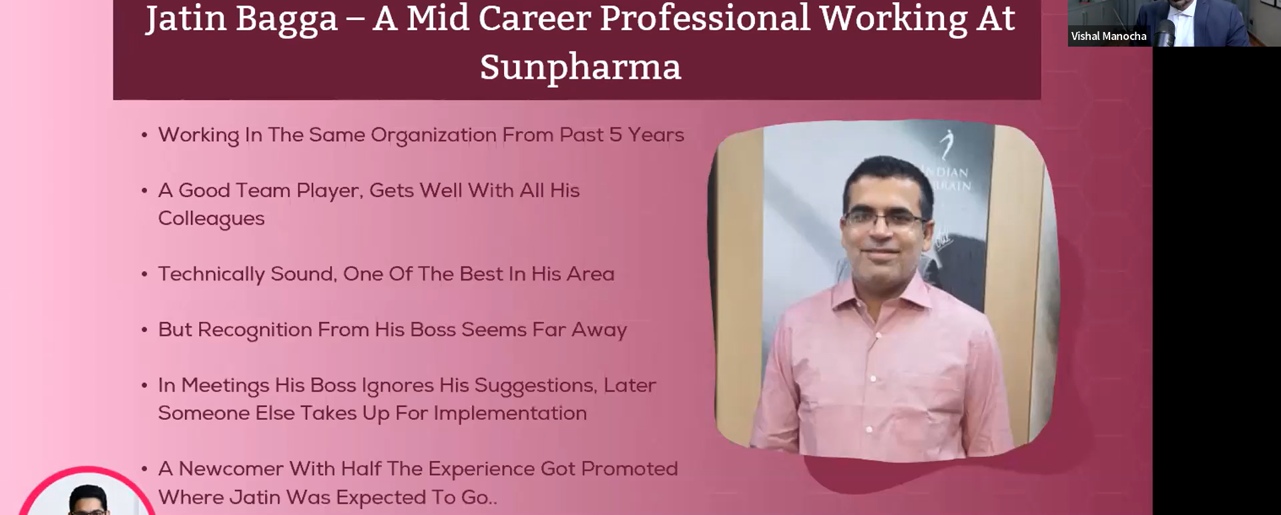
2. 
3. 
4. How many of you want this?
   1. My boss must make my work visible.
   2. My boss should make the maximum our of my potential.
   3. My boss should have enough time for me.
   4. My boss should care about my growth, my development.
5. How about if we replace “**My Boss**” with “I” 😊
   1. I must make my work visible.
   2. I should make the maximum our of my potential.
   3. I should have enough time for me.
   4. I should care about my growth, my development.
6. Let me give you framework that will give you at least 10% relationship improvement with your boss.  
   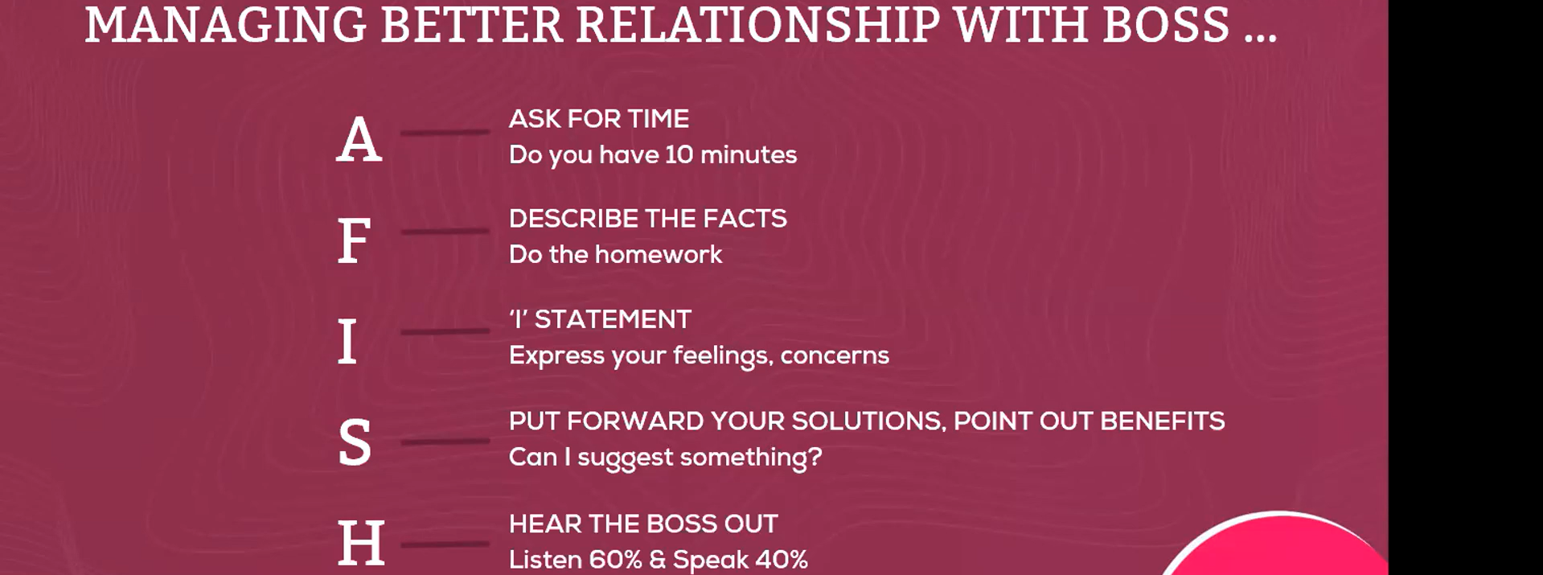
   1. A: Ask
7. **WIIFT**: **W**hat **i**s **i**n **i**t **f**or **t**hem.
   1. **WIIFM**: **~~W~~**~~hat~~ **~~i~~**~~s~~ **~~i~~**~~n~~ **~~i~~**~~t~~ **~~f~~**~~or~~ **~~Me~~**
8. We’re done with Disciplines.
   1. D: Differentiator.
   2. R: Relationship With Boss🡸 A fish
9. 
10. 
11. 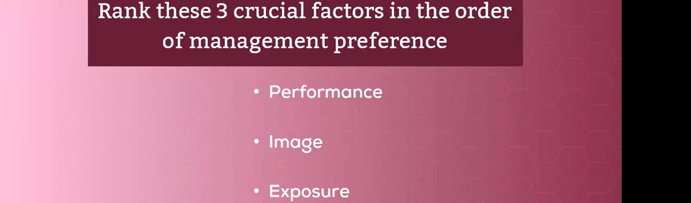
12. 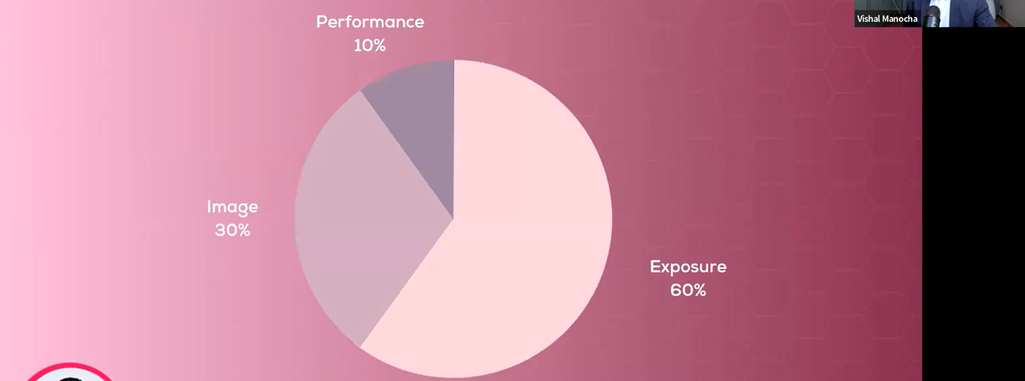
13. 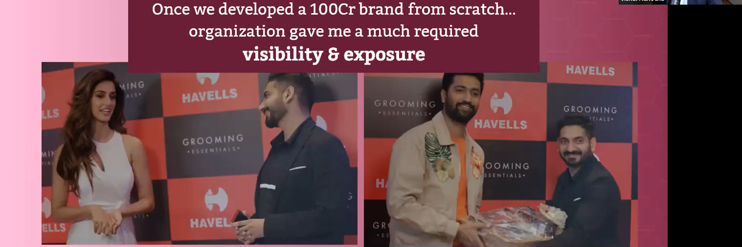
14. 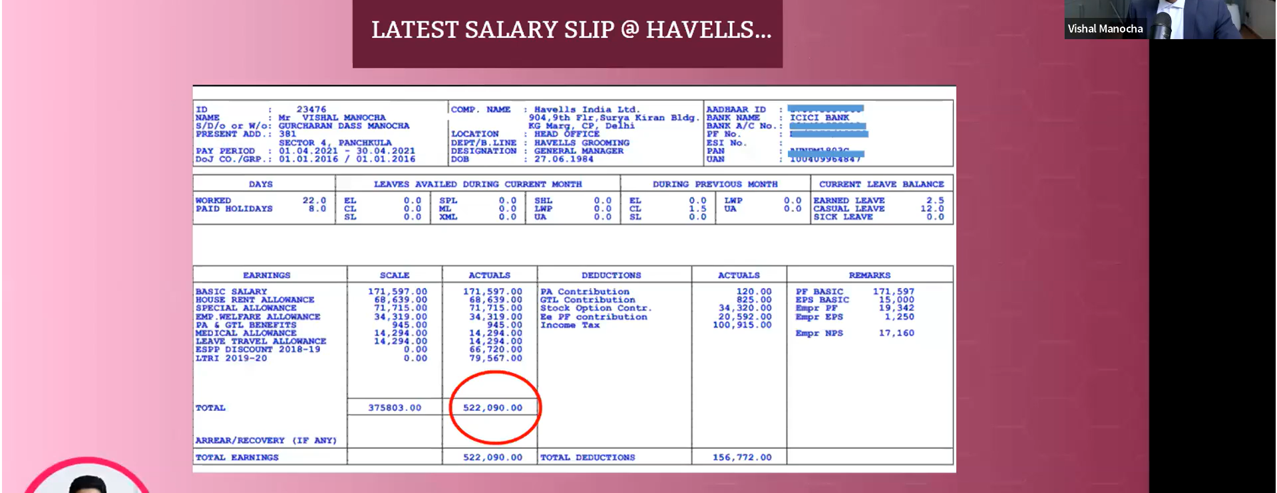
15. 
    1. Disciple, Relationship with Boss, Exposure to Senior Management, Smart Linked-in Profile.
16. 
17. 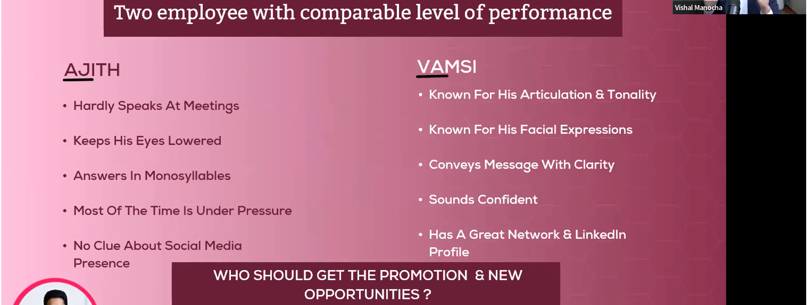
18. **Soft Skills**:
    1. Negotiation.
    2. Networking.
    3. Soft Skills.
    4. Linked-in Profile Development.
    5. Linked-in Content Writing.
19. 
20. 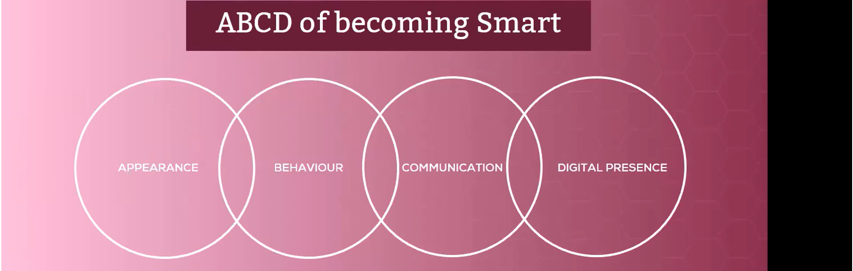
21. 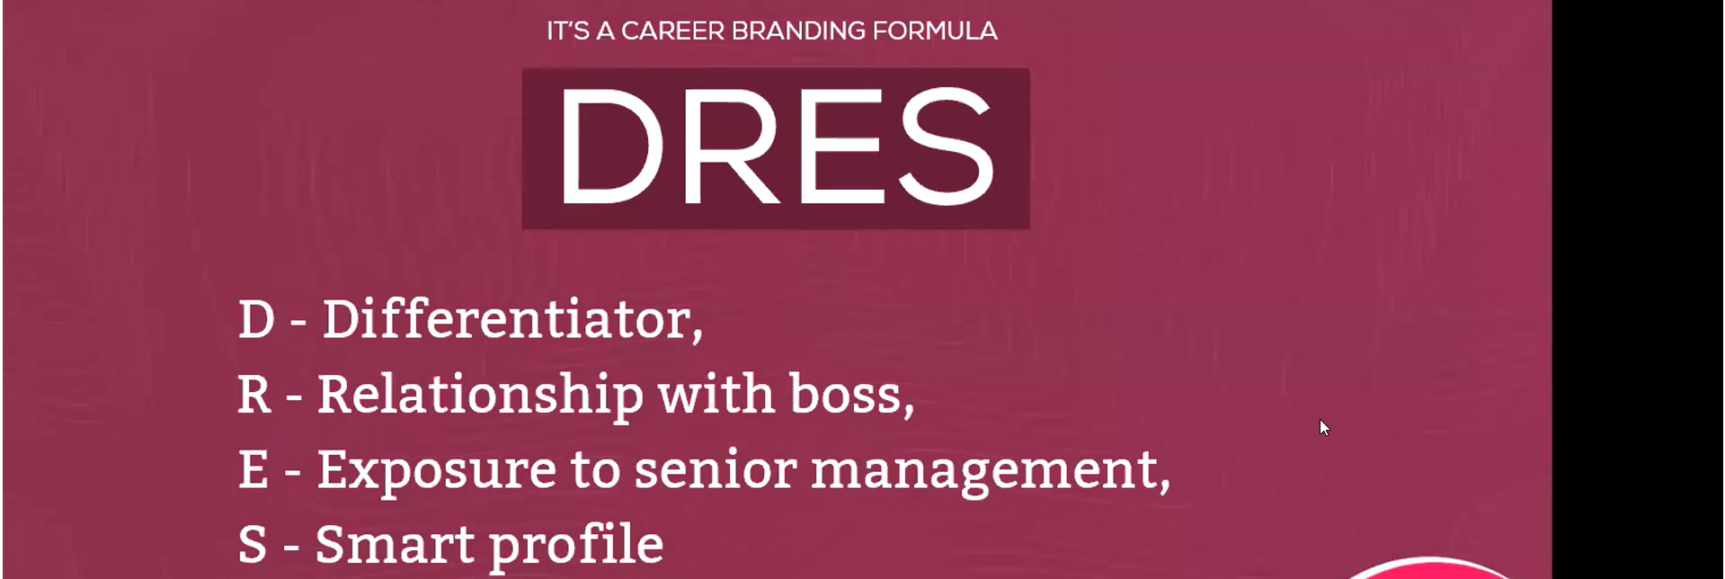
22. 
23. 
24. 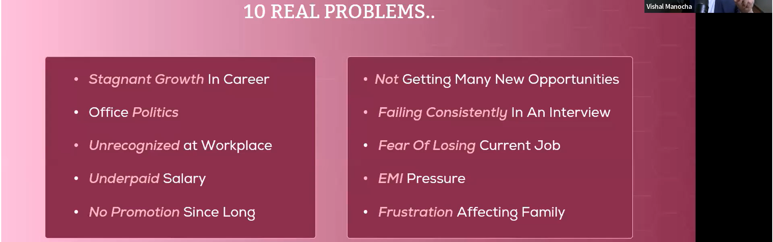
25. 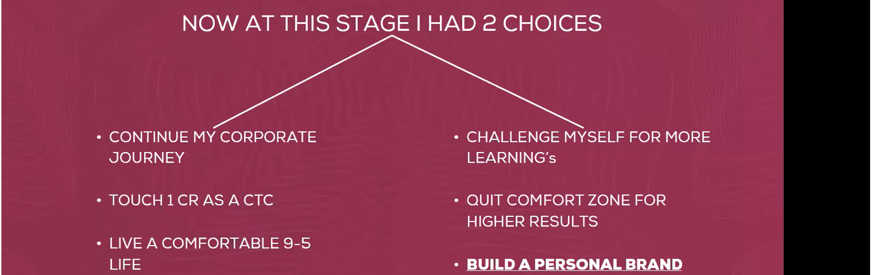
26. 
27. 
28. 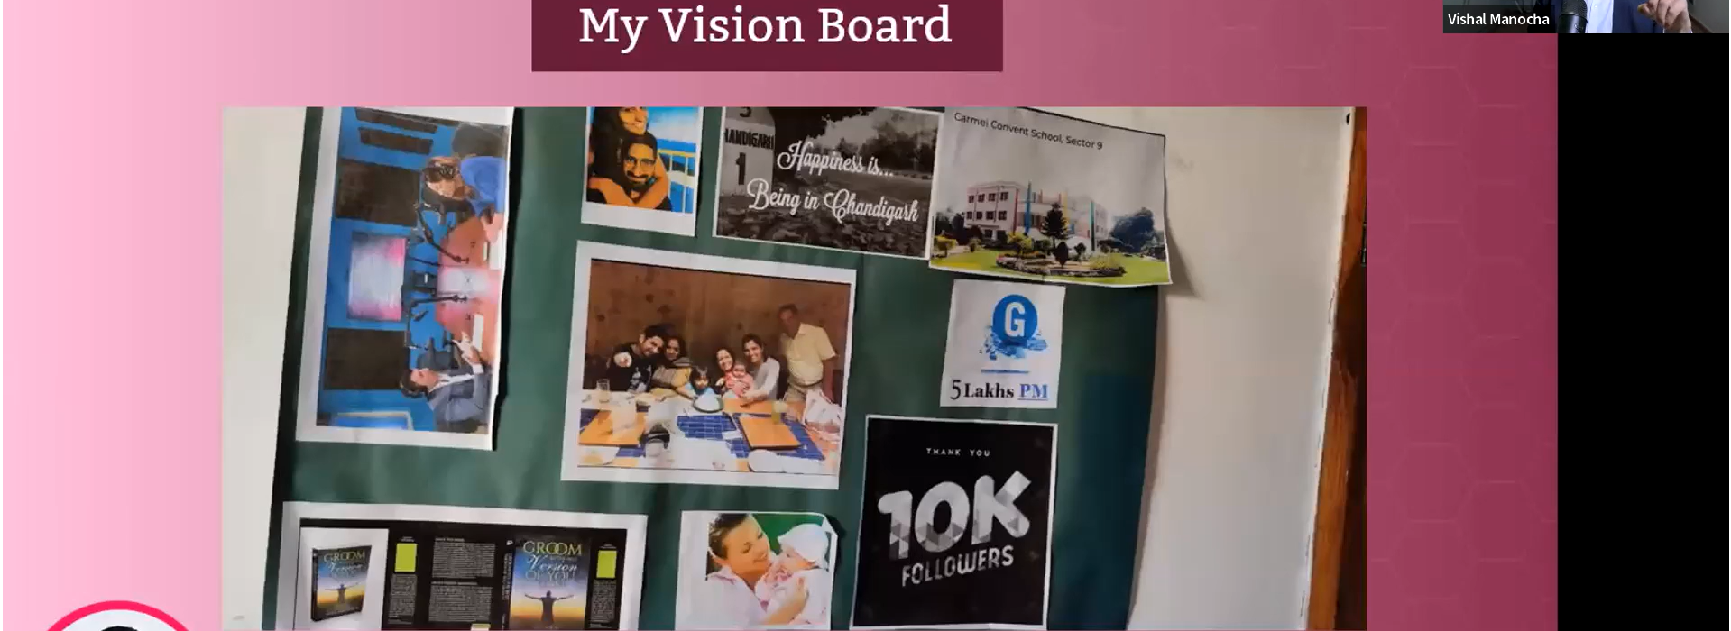
29. 
30. 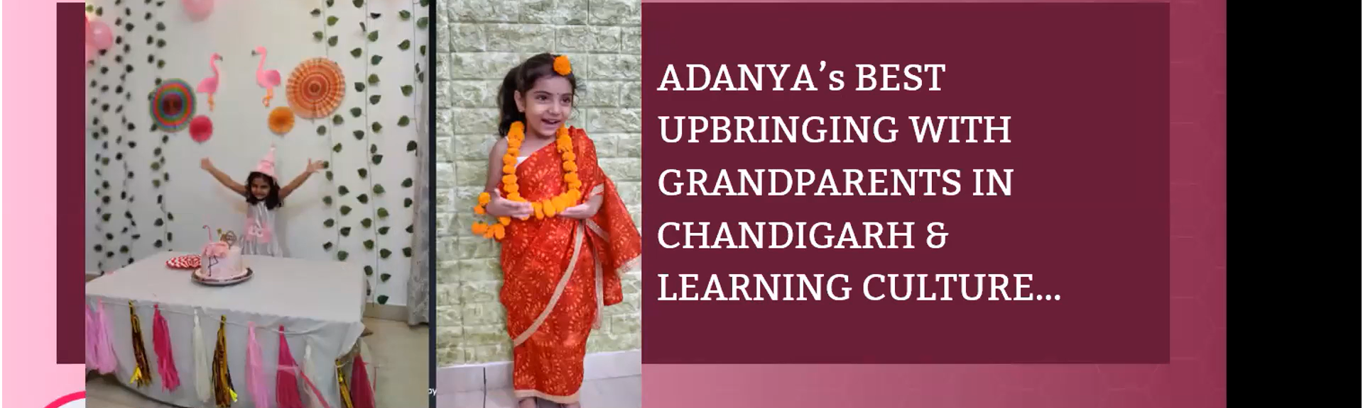
31. 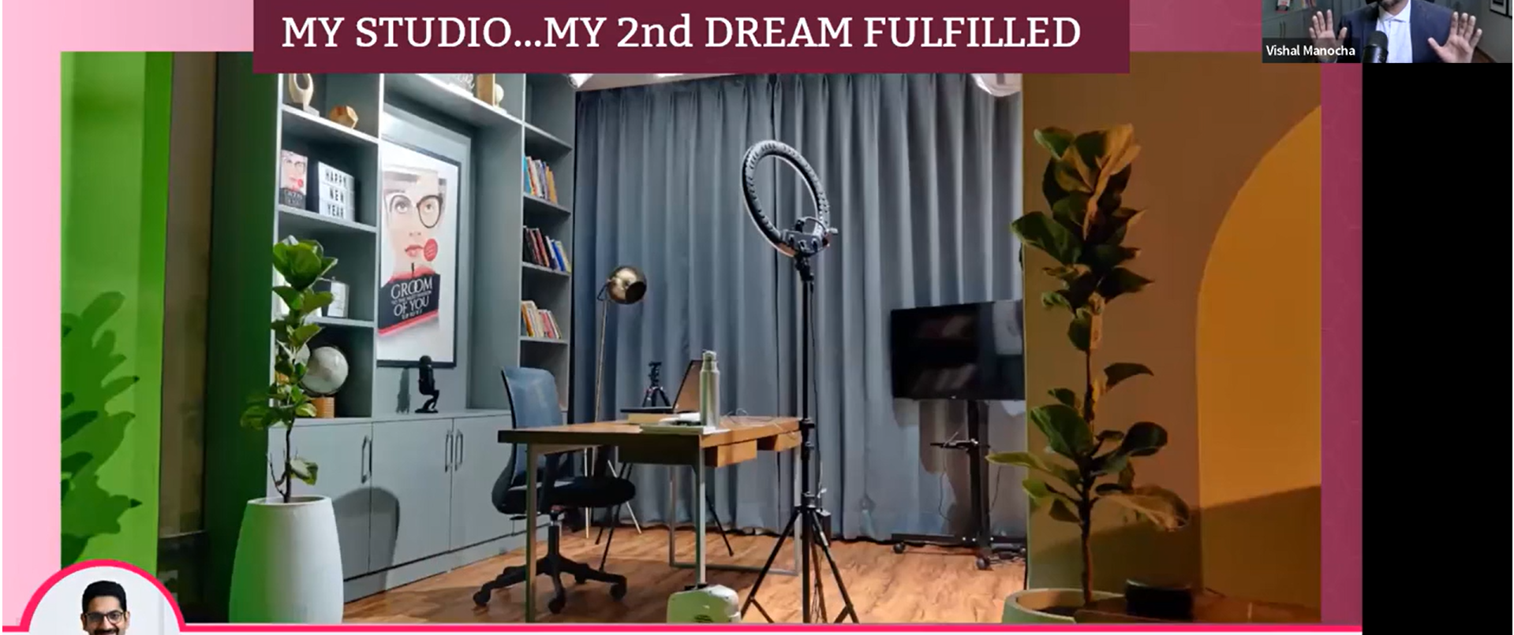
32. 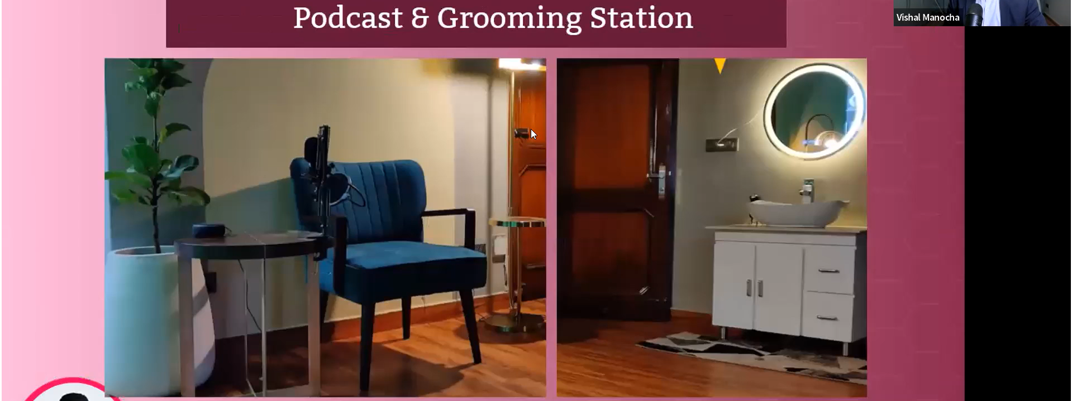
33. 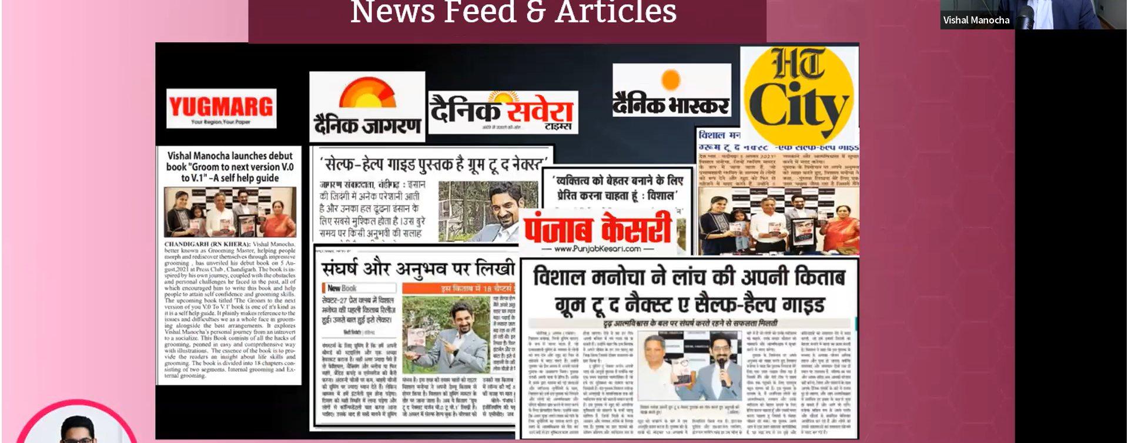
34. 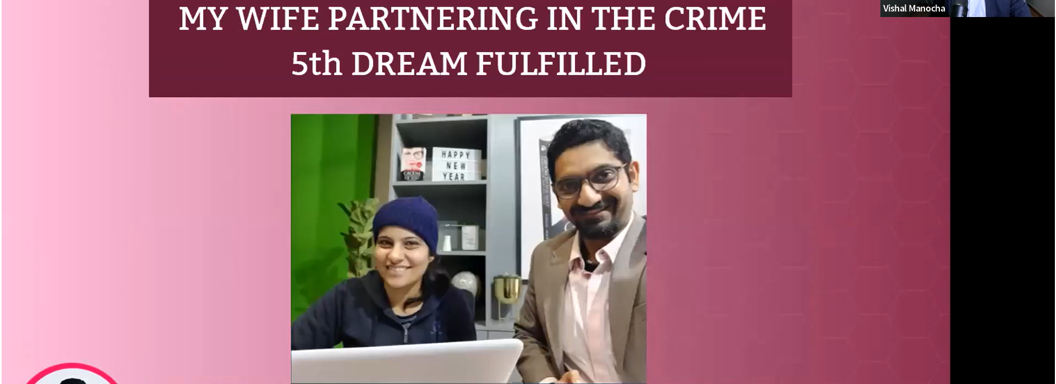
35. 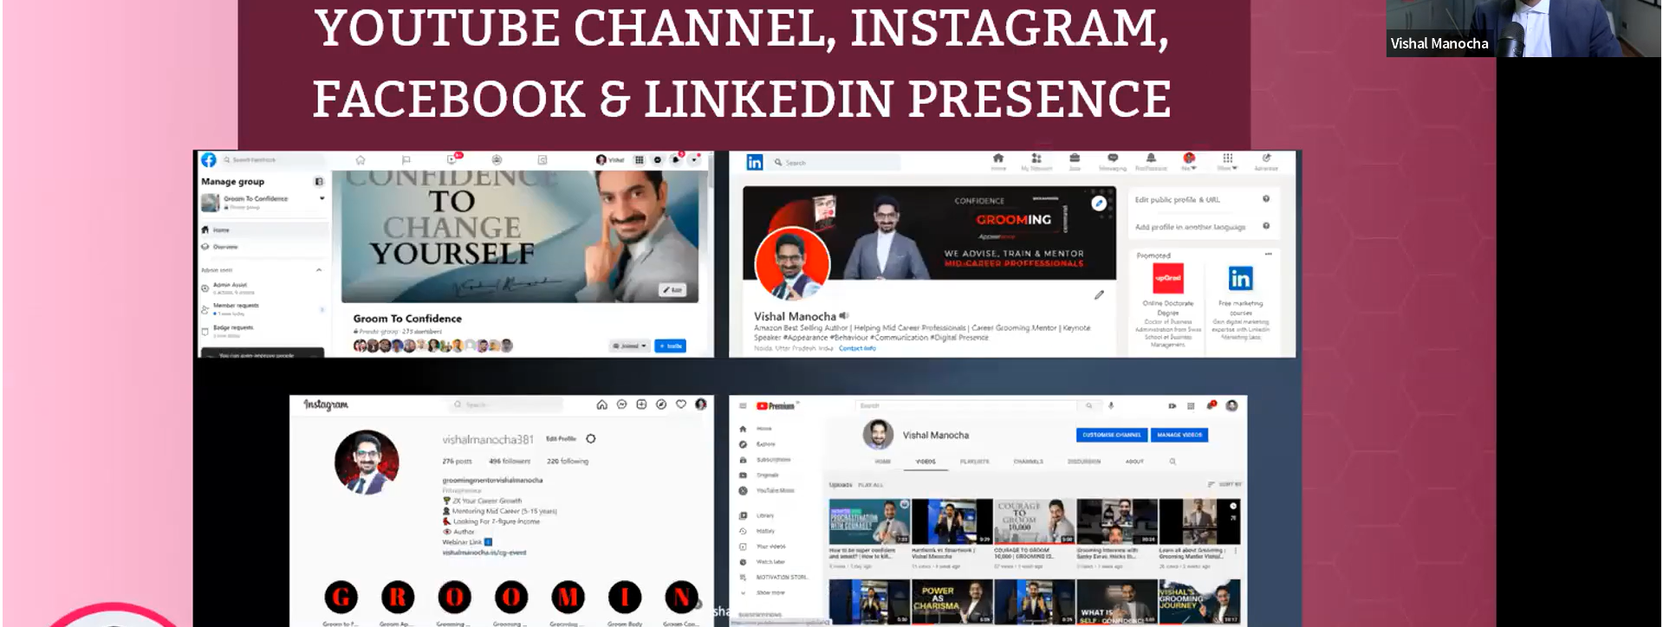
36. 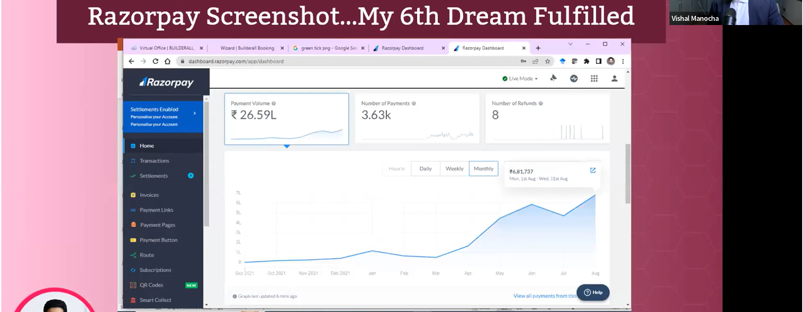
37. 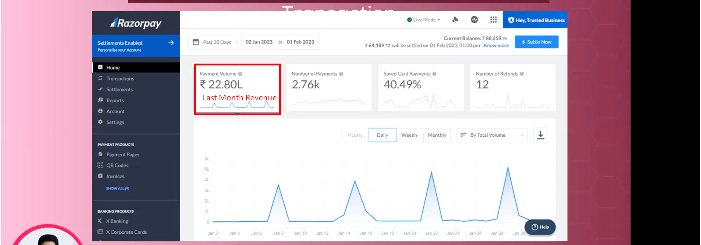
38. 
39. 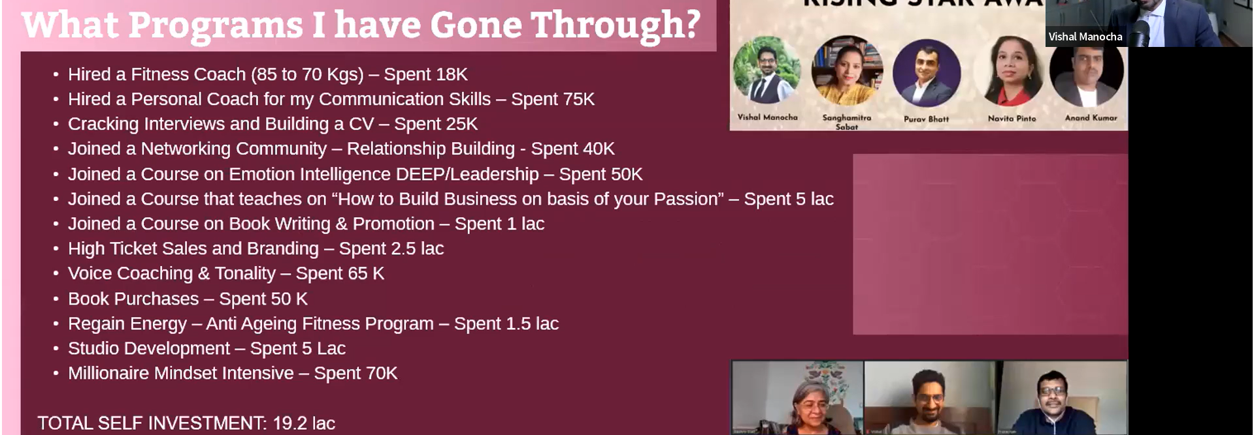
40. 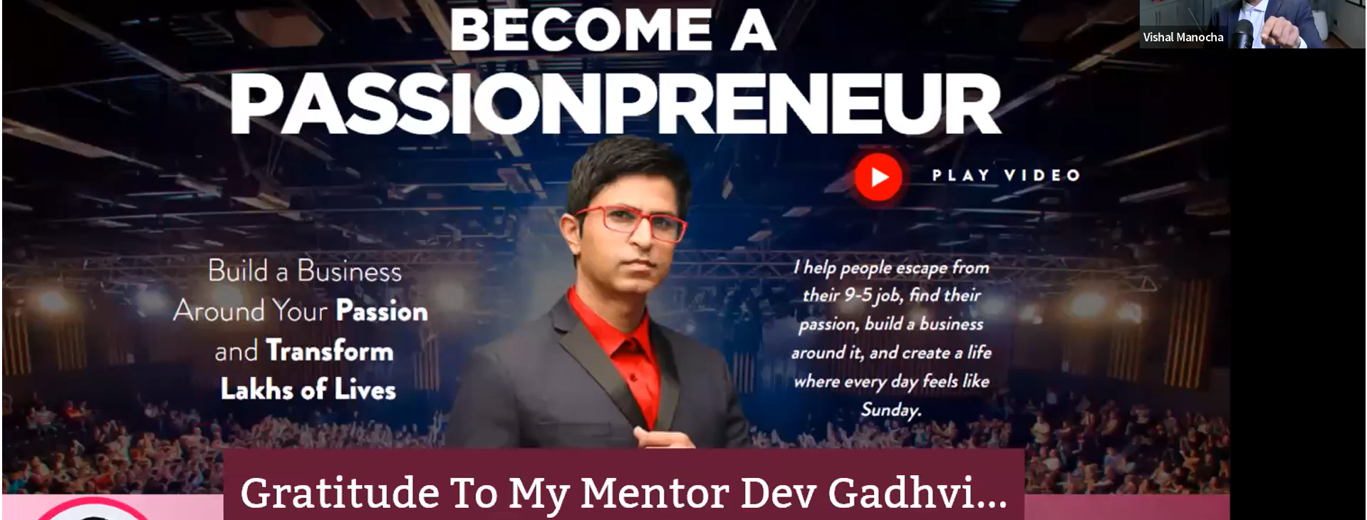
41. 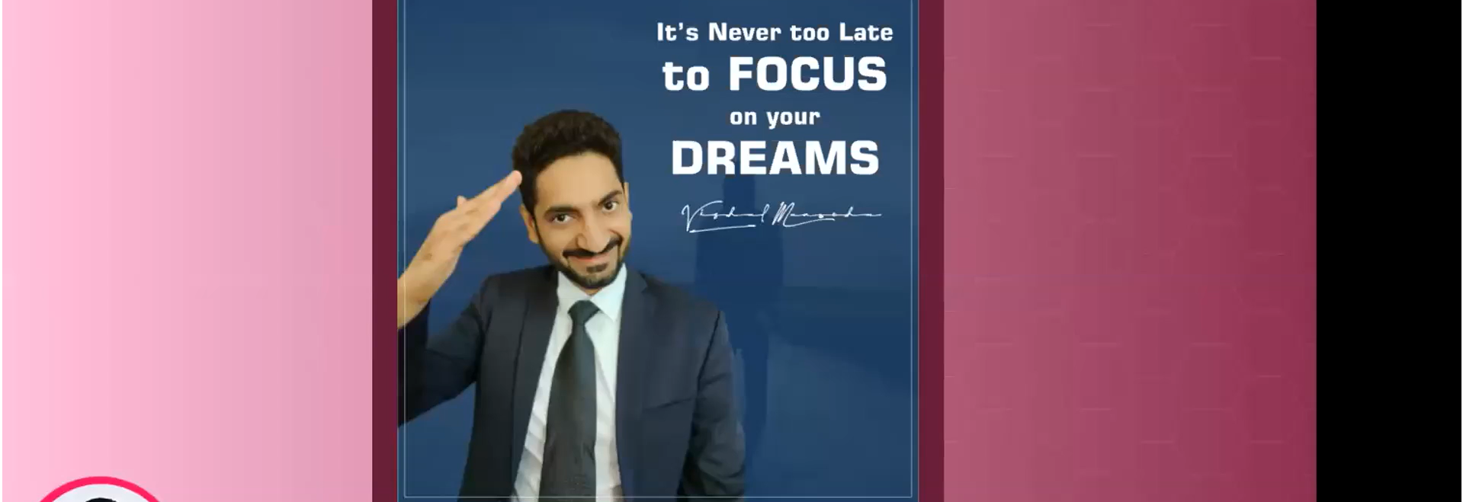
42. 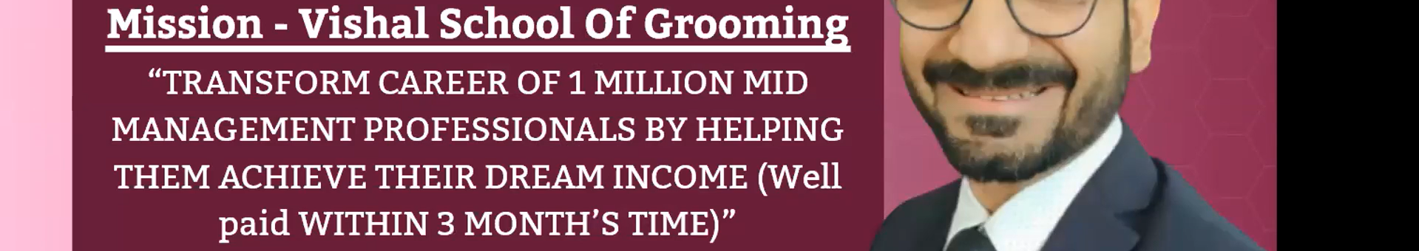
43. 
44. 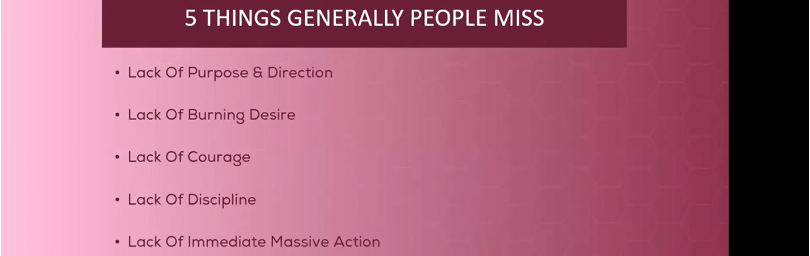
45. 
46. 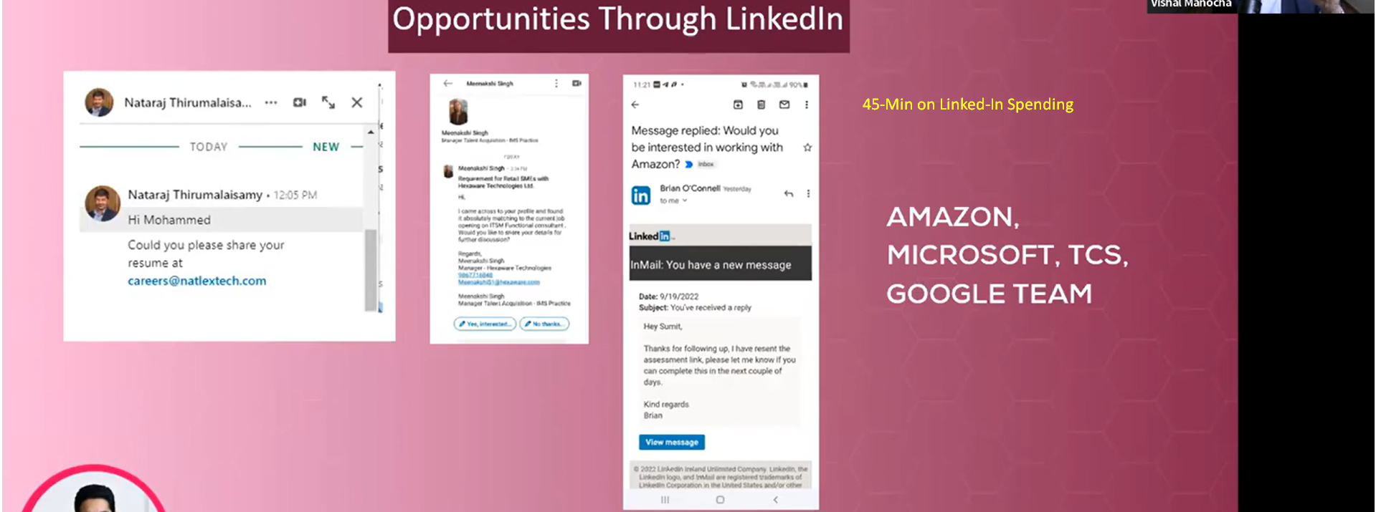
47. 
48. 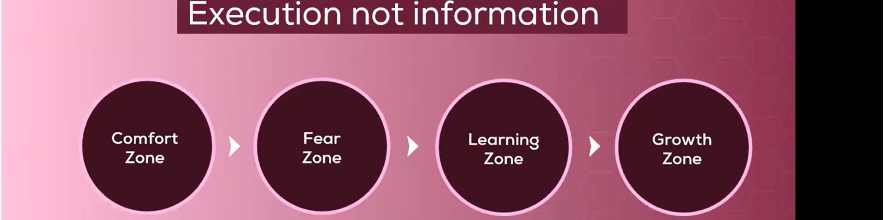
49. 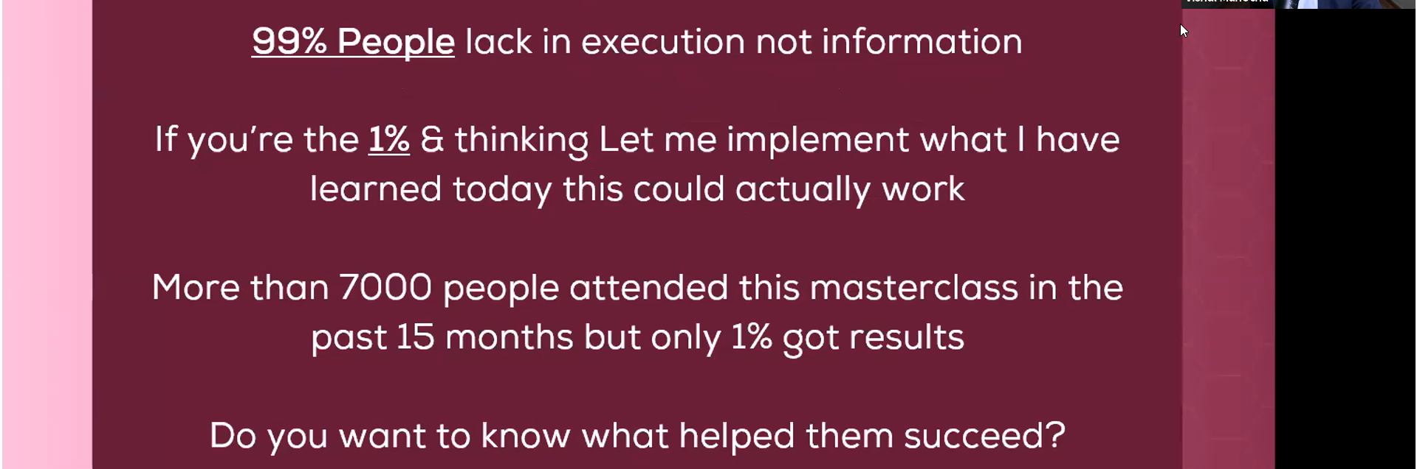
50. 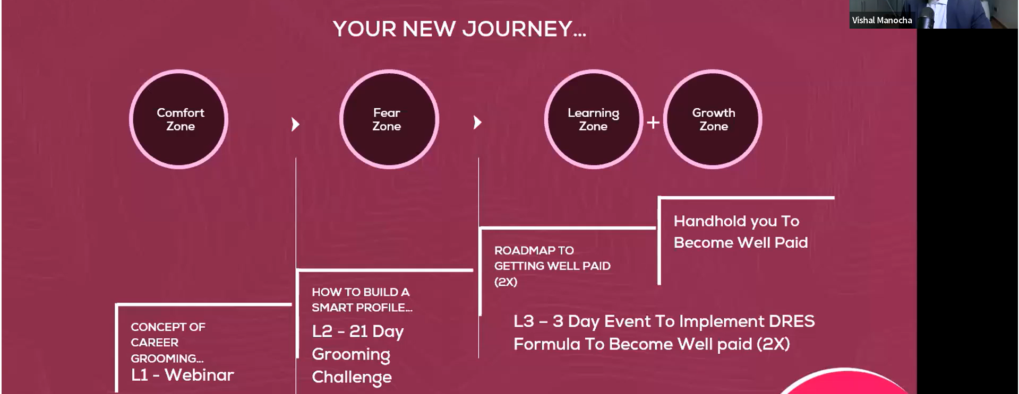
51. 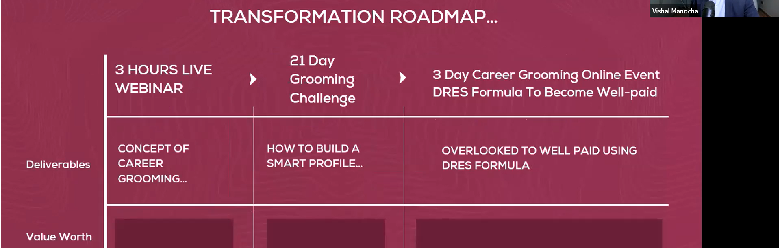
52. 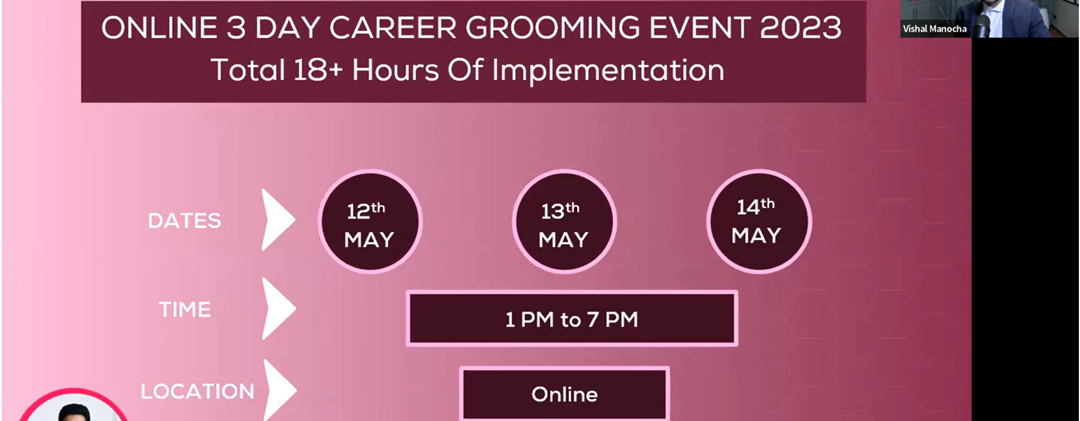
53. 
54. 
55. 
56. 
57. 
58. 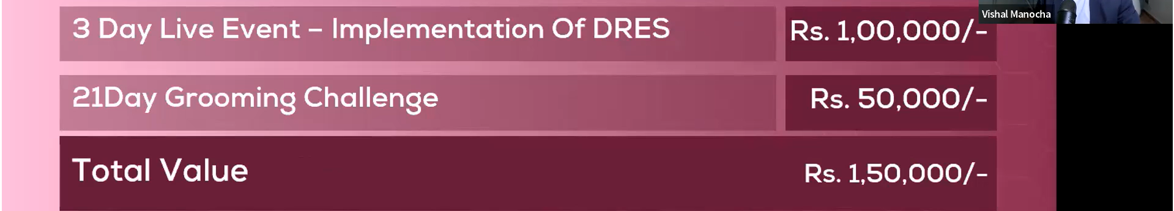
59. 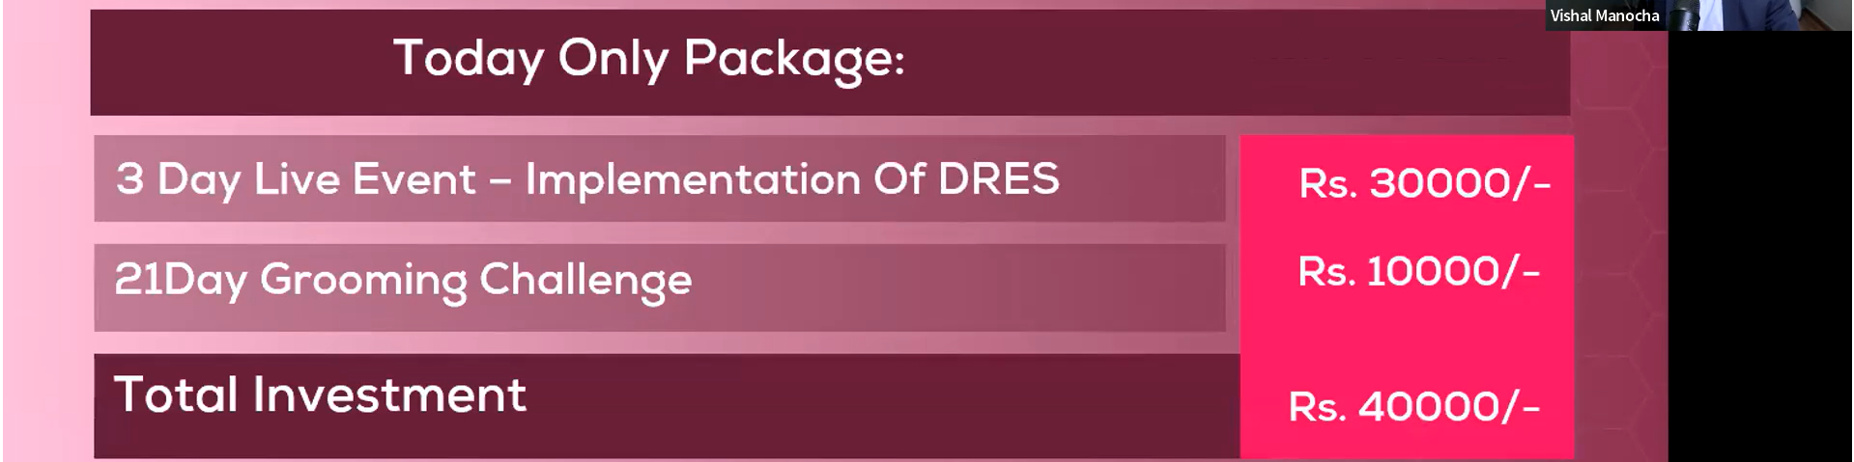
60. 
61. 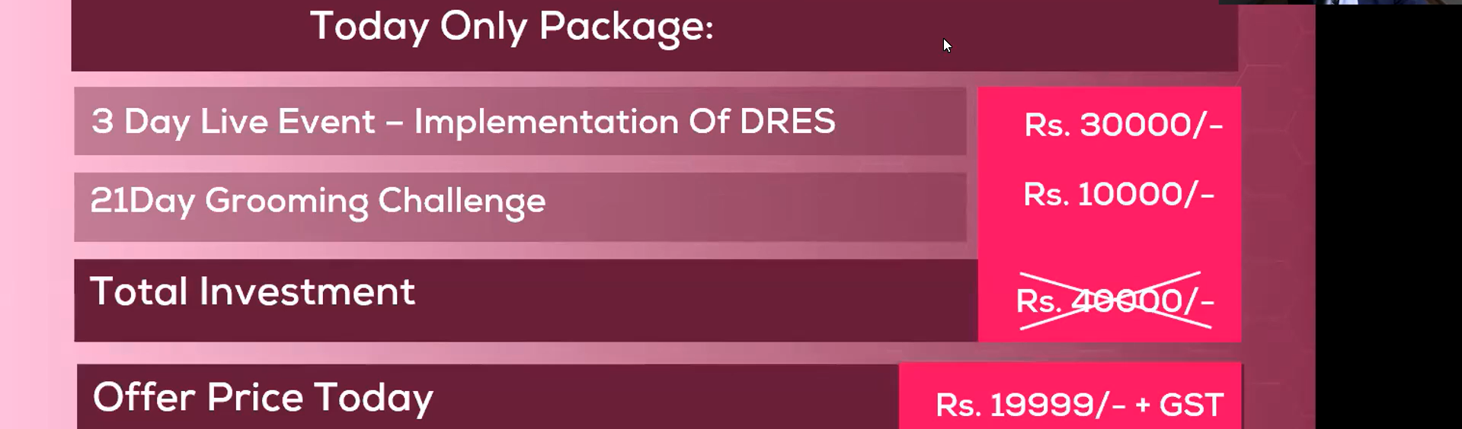
62. 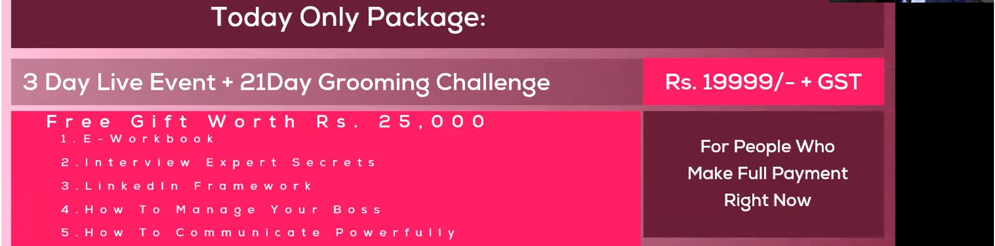
63. 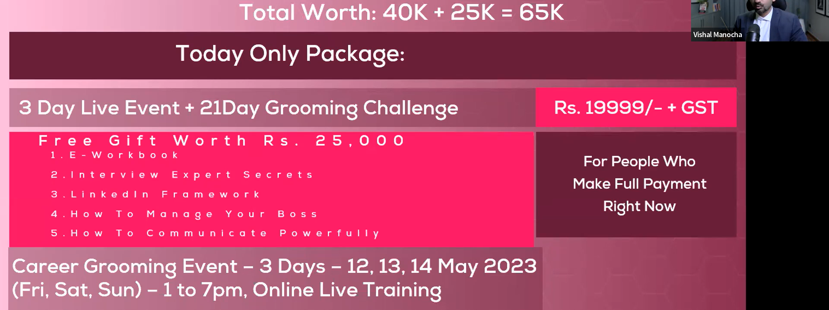
64. 
65. 